Translator Part
        - Overview
        - Module definitions
          - uop_queue
uop_queue is a FIFO queue that receives up to 4 micro instructions from the translator (xlator), and sends 1 micro instruction to the RISC core every clock cycle. If the queue is empty but there is a dequeue request from the RISC core, uop_queue generates nops with EOI 1.
uop_queue signals

Signal | Bits | In/out | Description | Connections
CLK | 1 | IN | clock
RST | 1 | IN | Active high, synchronous
flush | 1 | IN | Flush all instructions in the queue and make it empty | from RISC (flush, interrupt)
IN_uop0~3 | 39 | IN | uops (0 ~ 3) generated from xlator | from xlator
WR_EN0~4 | 1 | IN | write enable (0 ~ 3) for each instruction, indicating that instructions to be enqueued are ready.. | from xlator
pipe_stall | 1 | IN | when asserted, no instrcution is dequeued, and OUT_uop does not change* (same as the previous clock cycle)  If not asserted, uop_queue dequeues an instruction. | from RISC (pipe_stall)
OUT_uop | 39 | OUT | uop dequeued. If no instruction is available, a nop w/ EOI is generated | to RISC
Q_full | 1 | OUT | indicates that the queue is full. The current write requests are ignored. | to xlator (Q_full)

* uop_queue works as a pipeline latch between xlator and the decode/RF stage. OUT_uop should not change and be same as the previous clock cycle in order not to lose any instruction when a pipeline stall occurs.
          - z80_fetcher
z80_fetcher sends an read request to memory so that the pre-decoder reads an instruction byte. If the operation was successful, z80_fetcher increments fetchPC by 1 and repeats the operation. If flush is asserted, fetchPC is updated with targetPC.
z80_fetcher signals

Signal | Bits | In/out | Description | Connections
CLK | 1 | IN | clock
RST | 1 | IN | Active high, synchronous. fetchPC is cleared to 0.
flush | 1 | IN | when asserted, fetchPC is updated with the content of targetPC | from RISC (flush)
MREQ | 1 | OUT | read request to the memory interface | to memory interface (I_MREQ)
I_Addr | 16 | OUT | instruction address generated from fetchPC | to memory interface  (I_addr)
I_wait | 1 | IN | if asserted, fetchPC is not incremented | from memory interface (I_wait)
z80dec_stall | 1 | IN | if asserted, fetchPC is not incremented | from z80_decoder (z80dec_stall)
targetPC | 16 | IN | fetchPC is updated with the content of this signal when flush is asserted. | from RISC (targetPC)

          - z80_decoder.
z80_decoder signals

Signal | Bits | In/out | Description | Connections
CLK | 1 | IN | clock
RST | 1 | IN | Active high, synchronous.
flush | 1 | IN | invalidate instructions in the decoder and ignore I_byte
I_wait | 1 | IN | ignore I_byte if this is asserted | from memory
z80dec_stall | 1 | OUT | assert this if (I_word_rdy && xlator_stall) | to z80_fetcher
I_byte | 8 | IN | read a byte from this port if I_wait is false | from memory
I_word | 32 | OUT | z80 instruction word | to xlator
I_word_rdy | 1 | OUT | z80 instruction word / decode info ready | to xlator
z80_I_ID | 8 | OUT | z80 instruction identifier, used in translation | to xlator
xlator_stall | 1 | IN | xlator stall (conversely RD_EN_ from xlator when I_word_rdy is asserted) | from xlator

          - xlator
xlator signals

Signal | Bits | In/out | Description | Connections
CLK | 1 | IN | clock
RST | 1 | IN | Active high, synchronous.
flush | 1 | IN | invalidate instructions in xlator, and reset the state
uop0~3 | 39 | OUT | uops (0 ~ 3) | to uop_queue
WR_EN0~3 | 1 | OUT | indicating translated instructions are ready at each uop (0 ~ 3) ports | to uop_queue
NMI | 1 | IN | if NMI or INT is asserted, the current translation being processed in xlator is canceled, and xlator generates a sequence of instructions to save archPC onto the stack, jump to a trap located (determined by the type of interrupt). Meanwhile, xlator_stall is asserted so that no z80 instructions are read from the memory before the control is transfered to the trap location. | from interrupt handler in RISC core
INT | 1 | IN |  | from interrupt handler in RISC core
xlator_stall | 1 | OUT | xlator stall, indicating that there is a pending translation | to z80_decoder
I_word | 32 | IN | z80 instruction word | from z80_decoder
I_word_rdy | 1 | IN | z80 instruction word / decode info is ready | from z80_decoder
z80_I_ID | 8 | IN | z80 instruction identifier, used in translation | from z80_decoder
Q_full | 1 | IN | indicating that uop_queue is full. Since the current write requests are ignored, uop0~3 and WR_EN0~3 should be sustained. | from uop_queue

RISC Core Part
        - Module design strategy
The time is always against us, and it is likely that we are not going to achieve good designs in time.
Therefore, all modules will have many redundant inputs/outputs, and make each module decide what operation it will perform, as opposed to feeding necessary control signals into it.
        - Design overview
          - RF stage
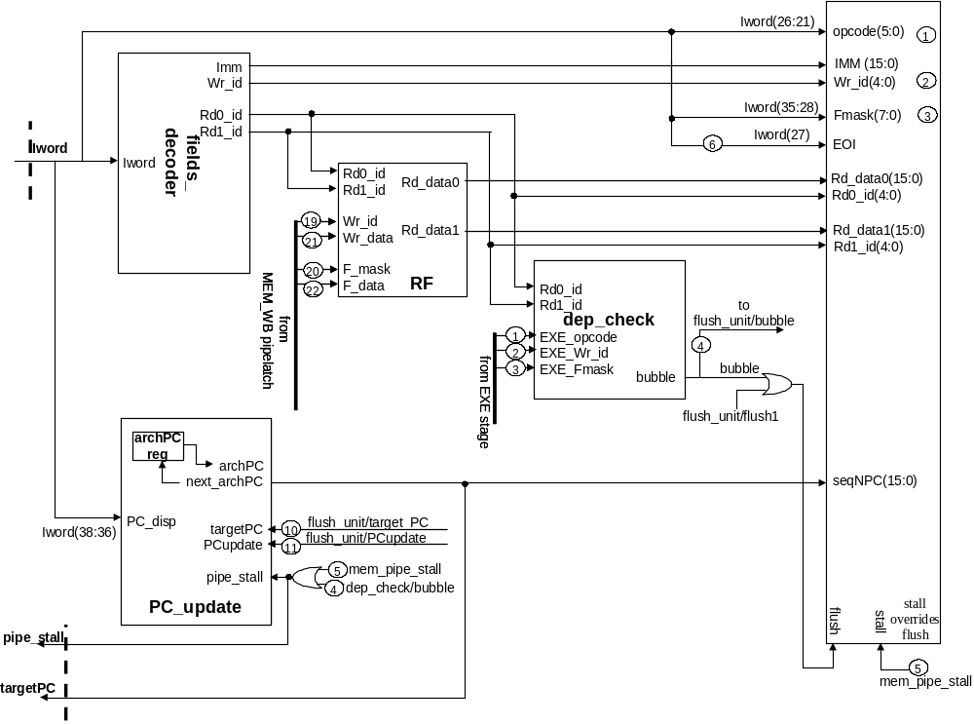

EXE stage
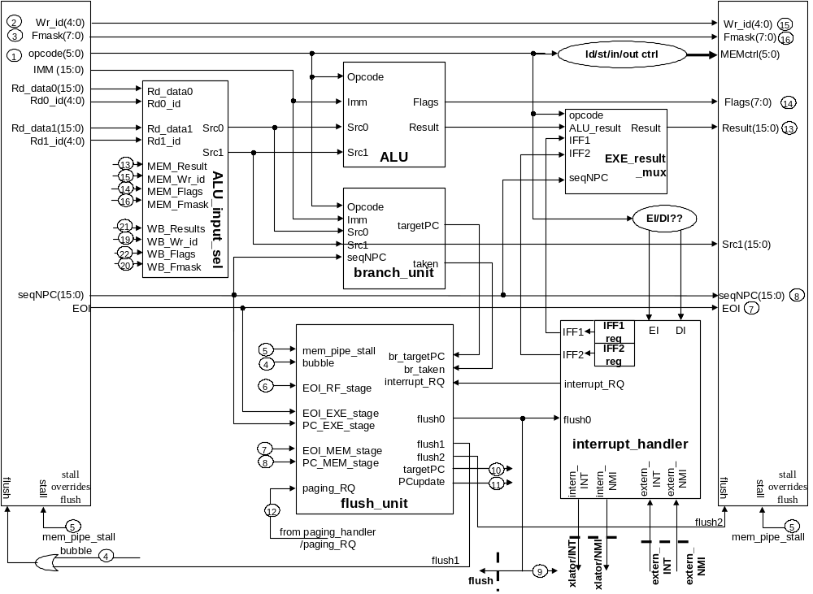

MEM stage
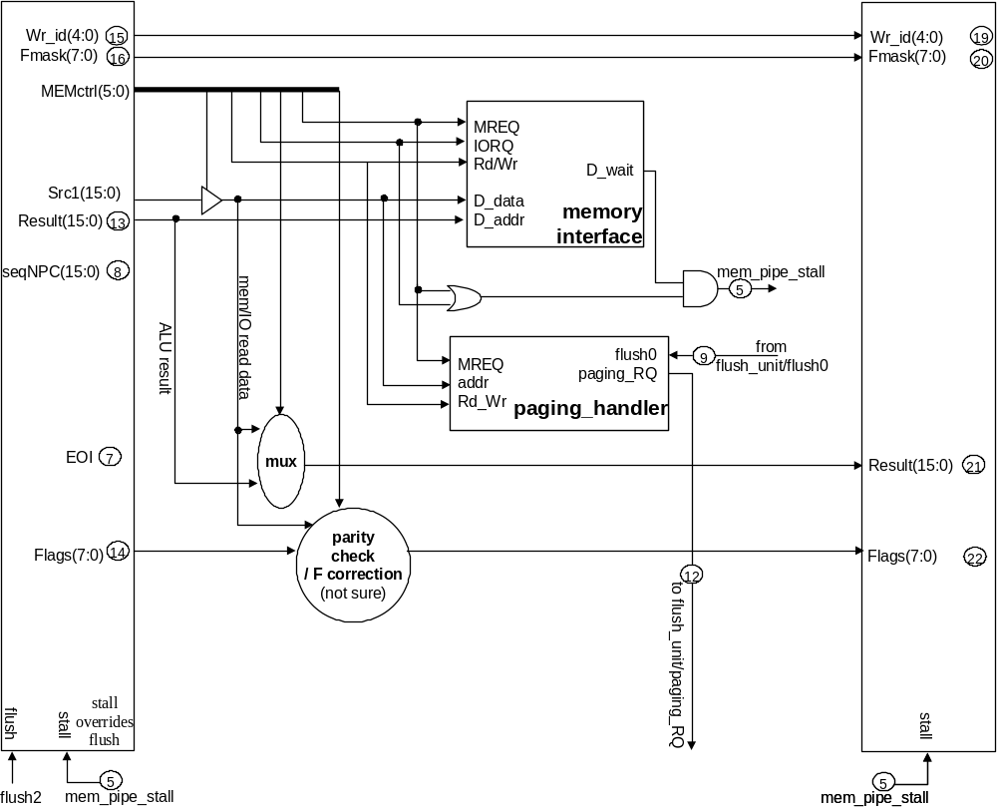

        - Module definitions
          - ALU
ALU handles arithmetic, logical, special, bit, load/store and I/O operations. ALU should be purely combinational.
All input and output values to ALU are always 16 bits even for 8-bit operations. All input values should be sign- extended to 16 bits if they comes from 8-bit values. When the 16-bit result from a ALU operation is written back to RF, the higher 8 bits will be cut off if the target register is 8-bit. Therefore, implementations for 8-bit ALU operations guarantees to be equivalent to reading 8-bit inputs and generating 8-bit outputs.
For example, the result value from add and add16 should be the same given same inputs (but flag bits should differ). However, the result value from add will be tailored to 8 bits when written back to RF. Since the inputs (8 bits) have been sign-extended to 16 bits, the final result is equivalent to add 8-bit values on a 8-bit ALU. It should be guaranteed that the correct flags are generated with regard to 8/16-bit operations. E.g. In 8-bit operations with 8-bit standard flag definitions, Z flag is generated by examining only result(7:0), ignoring result (15:8)
Which sources among Src0, Src1 and Imm are used for the computation is determined by Opcode.
ALU

Signal | Bits | In/out | Description | Connections
Src0 | 16 | IN | 16-bit source value0
Src1 | 16 | IN | 16-bit source value1
Imm | 16 | IN | 16-bit source value from IMM field. IMM8 should be sign-extended before connected. This field may work as either a source value, or as a part of opcode i.e. as in shiftrotate (ALU determins this 16-bit field will be used as 16 bits or 8 bits by looking at Opcode).
Opcode | 6 | IN | instruction opcode. This field (sometimes combined with Imm) determines which type of operation should be performed. For load/store or I/O operations, ALU performs AGENs
Flags | 8 | OUT | Condition code outputs
Result | 16 | OUT | 16-bit result value

Note that compare operations for branches are performed in a separate unit.
Outputs for instructions that the ALU does not support are unpredictable.
The following table defines instructions supported by the ALU and the port mapping. In this table, port Src0, Src1 and Imm implies that the ALU can read the 16-bit register / immediate values (defined in synopsis) from the ports specified.
ALU instructions & port mapping

type | Opcod e | Synopsis | Module | port  Src0 | port  Src1 | port  Imm | port  Result | note
ALU arith metic | 00 | add Ra, Rb, Rc |  | Rb | Rc |  | Ra
 | 01 | addi Ra, Rb, IMM8 |  | Rb |  | IMM | Ra
 | 02 | sub Ra, Rb, Rc |  | RRb | RRc |  | Ra
 | 03 | add16 RRa, RRb, RRc |  | RRb | RRc |  | RRa
 | 04 | addi16 RRa, RRb, IMM8 |  | RRb |  | IMM8 | RRa
 | 05 | sub16 RRa, RRb, RRc |  | RRb | RRc |  | RRa
 | 1A | subi Ra, Rb, IMM8 |  | Rb |  | IMM8 | Ra
 | 1B | subi16 RRa, RRb, IMM8 |  | RRb |  | IMM8 | RRa
ALU logi cal | 06 | and RRRa, RRRb, RRRc |  | RRRb | RRRc |  | RRRa
 | 07 | andi RRRa, RRRb, IMM8 |  | RRRb |  | IMM8 | RRRa
 | 08 | or RRRa, RRRb, RRRc |  | RRRb | RRRc |  | RRRa
 | 09 | ori RRRa, RRRb, IMM8 |  | RRRb |  | IMM8 | RRRa
 | 0A | xor RRRa, RRRb, RRRc |  | RRRb | RRRc |  | RRRa
 | 0B | xori RRRa, RRRb, IMM8 |  | RRRb |  | IMM8 | RRRa
 | 0C | not RRRa, RRRb |  | RRRb |  |  | RRRa
 | 0D | shiftrotate Ra, Rb, OP |  | Rb | F | OP | Ra | ALU reads carry bits from port Src1 (F regis ter).  For z80 instructions w/ a target reg of A by def initions (RLCA....), xla tor will explicitly setup A as a target.
 | 0E | get4 Ra, Rb, IMM8 |  | Rb |  | IMM8 | Ra
 | 0F | merge44 Ra, Rb, Rc |  | Rb | Rc |  | Ra
ALU spe cial | 11 | DAA Ra, Rb |  | Rb | F |  | Ra | ALU reads carry bits from port Src1 (F regis ter).  Both source / target A will be explicitly speci fied by xlator.
ALU bit operation | 12 | getbit Ra, Rb, IMM8 |  | Rb |  | IMM8 | Ra
 | 13 | ngetbit Ra, Rb, IMM8 |  | Rb |  | IMM8 | Ra
 | 14 | setbit Ra, Rb, IMM8 |  | Rb | Ra | IMM8 | Ra | Ra on Src1 for read- modified-write opera tions
 | 15 | nsetbit Ra, Rb, IMM8 |  | Rb | Ra | IMM8 | Ra | Ra on Src1 for read- modified-write opera tions
Address  calcula tion | 30 | ld Ra, (RRb + IMM8) |  | RRb |  | IMM8 | Address | perform add operation  the result from this operation goes to MEM/Addr
 | 31 | st Ra, (RRb + IMM8) |  | RRb | (Ra) | IMM8 | Address | perform add operation  the result from this operation goes to MEM/Addr.  Ra is not used for ALU but the value is accessed from RF
 | 16 | limm RRRa, IMM16 |  |  |  | IMM16 | RRRa
I/O | 32 | in Ra, (Rb + IMM8) |  | Rb |  | IMM8 | Address | perform add operation  the result from this operation goes to MEM/Addr
 | 33 | out Ra, (Rb + IMM8) |  | Rb | (Ra) | IMM8 | Address | perform add operation  the result from this operation goes to MEM/Addr.  Ra is not used for ALU but the value is accessed from RF

Register File
General purpose registers are accessed through the register file. Any updates to an entry are automatically reflected to corresponding entries. Read operations are not synchronous: changes in read register specifiers are directly reflected to outputs. However, write operations are synchronous wrt posedge of CLK. The register file supports bypass paths that bridge between write and read operations in a clock cycle. Logically, this is equivalent to writing a value in the first half of the clock period, and read a value for the other half of the clock period. Register specifier, structure definitions and port specifications are as follows:
General purpose registers

8-bit register group |  |  | 16-bit register group
register | specifier | description | register | specifier | description
R0 | 00000 | zero register that always contains 0. Can be used as a 16-bit register | SP | 11001 | z80 stack pointer
A | 01111 | z80 accumulator register | AF | 11100 | z80 {A,F}
F | 01101 | z80 condition code vector
B | 00001 | z80 | BC | 10000 | z80 {B,C}
C | 00011 | z80
D | 00101 | z80 | DE | 10100 | z80 {D,E}
E | 00111 | z80
H | 01001 | z80 | HL | 11000 | z80 {H,L}
L | 01011 | z80
I | 00100 | z80 | IX | 10001 | z80
R | 01000 | z80 | IY | 10101 | z80
T0 | 00010 | 8bit temp | T10 | 10010 | {T1,T0}
T1 | 00110 | 8bit temp
T2 | 01010 | 8bit temp | T32 | 11010 | {T3,T2}
T3 | 01110 | 8bit temp
 |  |  | AF’ | 11111 | z80 shadow AF
 |  |  | BC’ | 10011 | z80 shadow BC
 |  |  | DE’ | 10111 | z80 shadow DE
 |  |  | HL’ | 11011 | z80 shadow HL

RF

Signal | Bits | In/out | Description | Connections
CLK | 1 | IN | posedge CLK
RST | 1 | IN | synchronous reset
Rd0_id | 5 | IN | Read register specifier 0
Rd1_id | 5 | IN | Read register specifier 1
Rd_data0 | 16 | OUT | Read data out 0. When a 8-bit entry is accessed, the value is sign-extended
Rd_data1 | 16 | OUT | Read data out 1. same as above
Wr_id | 5 | IN | Write register specifier  Note: since RF does not have write enable signals, a write operation is disabled if this field is 00000.
Wr_data | 16 | IN | Write data in. When the target is 8-bit entry, Wr_data(15:8) is cut off internally before being stored
Fmask | 8 | IN | Flag update mask. see microISA definition
F_data | 8 | IN | Flag data to be written

Fields decoder
This module is pure combinational logic. It reads the whole instruction word, looks at the opcode, and generate 2 source identifier for RF read ports, 1 destination identifier for the RF write port, and a 16-bit immediate value from instruction word bit fields. 00000 is generated for idle ports. 16’b0 is generated for unused immediate value. The destination identifier (target register) for a RF write port will make a round trip back to the RF in writeback stage for a store operation. Also, source identifiers are passed to next pipeline stages for bypass modules
fields_decoder

Signal | Bits | In/out | Description | Connections
Iword | 39 | IN | full instruction word
Rd0_id | 5 | OUT | register identifier for Rd0 in RF. 00000 is generated if the port is unused. | to RF/Rd0_id
Rd1_id | 5 | OUT | register identifier for Rd1 in RF. 00000 is generated if the port is unused. | to RF/Rd1_id
Imm | 16 | OUT | If the instruction is RI type, this field is Iword[15:0].  If it is RRI type, this field is the sign-extended Iword[7:0]  If the instruction does not require an immediate value, this field is 0. | to ALU/Imm & branch_unit/Imm through the pipe latch
Wr_id | 5 | OUT | register identifier for Wr in RF. 00000 is generated if the write port is unused.

Shiftrotateand DAA instructions may require the condition code for their computations. Although these instructions are RRI type and has only 1 source operand (Rd0_id), the instructions in fact assume F register as a source operand implicitly. Therefore, this module generates F register ID (01101) in Rd1_id to read F register needed for their computations.
ALU input selector (bypass logic)
This module is located right before the decode-execution pipe latch. It determines which values (from RF or ALU/Result or ALU/Flags or Mem/Rd_data or Mem/Flags) will be fed into ALU inputs (and branch_unit also). Pure combinational logic.
Due to RF configurations, this module should implement partial bypass from 8/16bit results to 16/8bit source, such as L <- HL or HL <- H. In case of ??bit to 8bit register forwardinig, the forwarded value should be sign-extended before put on ouput ports, In addition, this module also allows bit-wise bypass from previous Flag values, considering Fmask.
ALU_input_sel

Signal | Bits | In/out | Description | Connections
Src0 | 16 | OUT | selected source value0 | to ALU/Src0 through the pipe latch
Src1 | 16 | OUT | selected source value1 | to ALU/Src1through the pipe latch
Rd_data0 | 16 | IN | source value candidate from RF | from RF/Rd_data0
Rd0_id | 16 | IN | source0 ID from RF | from RF/Rd0_id
Rd_data1 | 16 | IN | source value candidate from RF | from RF/Rd_data0
Rd1_id | 16 | IN | source1 ID from RF | from RF/Rd1_id
MEM_Result | 16 | IN | source value candidate from MEM | from ALU’s result in MEM
MEM_Wr_id | 5 | IN | target register ID of the MEM_Result | from Wr_id in MEMstage
MEM_Flags | 8 | IN | source value candidate (flag data) from MEM | from MEM/Flags
MEM_Fmask | 8 | IN | flag mask of MEM_Flags | from Fmask in MEM stage.
WB_Result | 8 | IN | source value candidate from WB | from the result value in WB stage
WB_Wr_id | 5 | IN | target register ID of the WB_Result | from Wr_id in WB stage
WB_Flags | 8 | IN | source value candidate (flag data) from WB | from Flags in WB stage
WB_Fmask | 8 | IN | flag mask of WB_Flags | from Fmask in WB stage

Implementation note on bypass / forwarding:
Two bypass paths are installed between:
From the beginning of MEM stage (ALU output) to the beginning of EXE stage.
From the beginning of WB stage (memory read data / ALU output) to the beginning of EXE stage.
If dependences from both mem and execution stages are detected, values in execution stage has higher priority than those in memory stage in forwarding.
Parity setting in IN instruction should be handled. Let’s forget about this problem for now.
We don’t implement memory to memory bypass paths (memory move operations implemented by a series of load and stores). Instead, the control logic artificially injects pipe stalls to prevent these conditions.
MEM_Result is a out from the mux between the memory read data and ALU output.
IN and ld instructions do not generate results in the EXE stage, and this unit may incorrectly decide to forward the ALU result (agen result). However, this is also the bubble condition detected by dep_check module, which makes the current incorrect forwarding invalid. Therefore, the case does not happen.
Forwarding data merging may occur. i.e. an instruction in WB changes H, another instructiono in MEM changes L, and the instruction in EXE reads HL. This may happen as a bit-wide merging operation in F register.
          - Branch unit
Pure combinational logic. This module generates target PC values for branches / jumps, computes conditions and determines if the control flow changes. Although the condition checking can be done in ALU rather than in this unit, I decided that this unit takes care of everything since all instructions do just simple equality checks, and do not require arithmetic operations (like less than or greater...)
branch_unit

Signal | Bits | In/out | Description | Connections
Src0 | 16 | IN | 16-bit source value0 | same as ALU/Src0
Src1 | 16 | IN | 16-bit source value1 | same as ALU/Src1
Imm | 16 | IN | 16-bit immediate value. Used to generate targetPC | same as ALU/Imm
Opcode | 6 | IN | opcode, determines how to generate PC and conditions | same as ALU/Opcode
seqNPC | 16 | IN | next sequential PC, which has been updated by PC_disp | from
targetPC | 16 | OUT | seqNPC + branch offsets from Iword for branches,  or targetPC for jumps, regardless of taken/untaken
taken | 1 | OUT | true if the branch / jump is taken because the condition is true or it is always taken

          - Flush unit
pure combinational logic. The flushing unit determines the followings:
from which stage the instruction should be flushed: 3 flushing locations. flush0, flush1 and flush2, in instQ/RF, RF/EXE, EXE/MEM pipe latches, respectively. There are precedence in flush 0, 1 and 2, i.e. when flush1 is asserted, flush0 is also asserted. When a flush is asserted (synchronous), the pipeline latch will generate a nop in the next clock cycle, ignoring the current instruction that was supposed be passed to the next stage.
determines if this flush updates archPC with new PC value
PC of the first instruction to be inserted after the flush, if updating archPC is needed.
Note that the outgoing flush signal to the traslation part is flush0. Since flush1 and 2 are ORed to flush0, any of flush conditions also assert flush0.
                - flush_unit

Signal | Bits | In/out | Description | Connections
flush0 | 1 | OUT | flushes instQ (and all translation pipeline) | if a later-stage flush is asserted, earlier-stage flush signals are also asserted
flush1 | 1 | OUT | flushes RF/EXE pipe latch
flush2 | 1 | OUT | flushes EXE/MEM pipe latch
targetPC | 16 | OUT | targetPC of branch/jump/paging (PC of the first inst after the paging) | to PC_update/targetPC
PCupdate | 1 | OUT | asserted if nextPC should be reflected to archPC (branch/jump or paging) | to PC_update/PCupdate
br_targetPC | 16 | IN | targetPC from branch_unit | branch_unit/targetPC
br_taken | 1 | IN | taken/untaken from branch_unit | branch_unit/taken
paging_RQ | 1 | IN | signals that there is a (pending) paging request | from paging_detect/paging
interrupt_RQ | 1 | IN | signals that there is a (pending) interrupt request | from interrupt handler
mem_pipe_stall | 1 | IN | memory stall condition | from memory stage
bubble | 1 | IN | mem-to-alu dependence condition | from dep_check logic
EOI_RF_stage | 1 | IN | EOI bit of the instruction in RF stage
EOI_EXE_stage | 1 | IN | EOI bit of the instruction in EXE stage
EOI_MEM_stage | 1 | IN | EOI bit of the instruction in MEM stage
PC_EXE_stage | 16 | IN | PC (next seqPC) of the instruction in EXE stage
PC_MEM_stage | 16 | IN | PC (next seqPC) of the instruction in MEM stage

                - flush_unit description

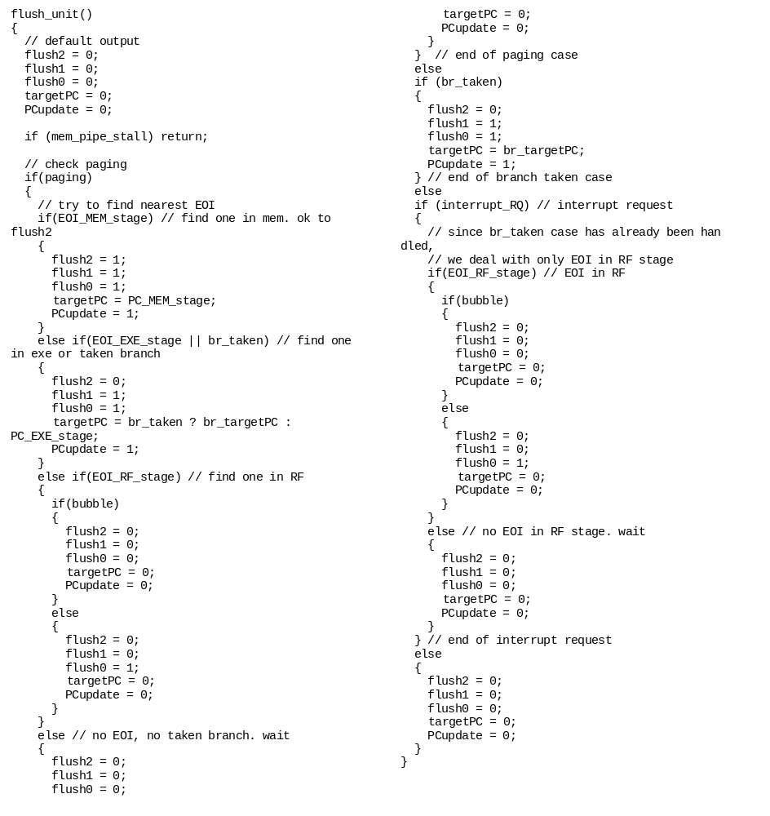

          - PC update unit
PC update unit is responsible for maintaining the correct archPC state. archPC is updated by PC_disp field in the instruction word. Usually, the first instruction in the translation group has a non-zero PC_disp that updates the current archPC to the next sequential PC value. This unit contains archPC, a special purpose register inside.
PC_update

Signal | Bits | In/out | Description | Connections
CLK | 1 | IN | CLK
RST | 1 | IN | reset archPC to 0
PC_disp | 3 | IN | PC displacement. addeded to the curr PC (archPC). Since these 3 bits are UNSIGNED, it should be 0 extended to 16 bits before it goes to adder
archPC | 16 | OUT | the current content of archPC.  archPC <= next_archPC every clk cycle | from the output of archPC (register)
next_archPC | 16 | OUT | if (pipe_stall) next_archPC <= archPC  elseif(PCupdate) next_archPC <= targetPC  else next_archPC <= sequential PC from the adder | to the input of archPC (register)
targetPC | 16 | IN | targetPC of branch/jump/paging | from flush_unit/nextPC
PCupdate | 1 | IN | if true (and !pipe_stall), n_archPC <= nextPC | from flush_unit/PCupdate
pipe_stall | 1 | IN | pipe stall condition? | (= mem_pipe_stall | bubble)

          - Interrupt handler
This unit samples INT/NMI signal from outside every posedge CLK, checks the current state of IFF1/IFF2 to determine if interrupt requests should be serviced. If ((INT && IFF1) | NMI), the unit sends an interrupt_RQ to flush_unit, and holds it until flush0 is asserted before the interrupt_RQ is reset. intern_INT and intern_NMI to the translation part are generated in the same clock cycle when flush0 occurs so that flush0 / intern_INT / intern_NMI are latched simultaneously at posedge CLK.
This unit contains IFF1 and IFF2, and supports IFF manipulations
interrupt_handler

Signal | Bits | In/out | Description | Connections
CLK | 1 | IN | CLK
RST | 1 | IN | resets interrupt_RQ, IFF1, IFF2
extern_INT | 1 | IN | external INT | z80 definition
extern_NMI | 1 | IN | external NMI | z80 definition
intern_INT | 1 | OUT | internal INT. generated in sync with flush0 | to xlator/INT
intern_NMI | 1 | OUT | internal NMI. generated in sync with flush0 | to xlator/NMI
interrupt_RQ | 1 | OUT | set when ((INT && IFF1) | NMI).  reset when flush0 occurs | to flush_unit/interrupt_RQ
flush0 | 1 | IN | sees if the interrupt can be handled.
IFF1 | 1 | OUT | current content of IFF1
IFF2 | 1 | OUT | current content of IFF2
EI | 1 | IN | enable interrupt (set IFF) | asserted by EI instruction in EXE stage
DI | 1 | IN | disable interrupt (reset IFF) | asserted by DI instruction in EXE stage

          - paging handler
It monitors if memory is being written at 0xFFF? (should find some info -- ikim) and asserts paging_RQ to flush_unit in the same clock cycle. paging_RQ is reset when flush0 occurs.
paging_handler

Signal | Bits | In/out | Description | Connections
CLK | 1 | IN | CLK
RST | 1 | IN | resets paging_RQ
MREQ | 1 | IN | access request to memory
addr | 16 | IN | 16-bit memory address
Rd_Wr | 1 | IN | checks if the request is read / write
paging_RQ | 1 | OUT | paging request | to flush_unit
flush0 | 1 | IN | reset paging_RQ if this signal comes in

          - dependence check
It checks if any source operands of an instruction in RF stage are dependent on a load target operand in EXE stage. When detected, it asserts bubble to create a bubble into pipelatch1 between RF and EXE stages, in order to cover the incomplete bypass and avoid structural hazards.
dep_check

Signal | Bits | In/out | Description | Connections
EXE_opcode | 6 | IN | opcode of the instruction in EXE stage to see it is load / IN instruction.
EXE_Wr_id | 5 | IN | destination register id of the inst in EXE stage
EXE_Fmask | 8 | IN | Fmask of the instruction in EXE stage
Rd0_id | 5 | IN | src register id of the inst in RF stage
Rd1_id | 5 | IN | src register id of the inst in RF stage
bubble | 1 | OUT | asserts if a dependence is detected

Note that bubble affects pipelaatch1 only when mem_pipe_stall does not occur. bubble is basically identical to flush1 that puts a nop w/ !EOI.
          - misc signals
misc signals

Signal | Bits | In/out | Description | Connections
pipe_stall | 1 |  | = mem_pipe_stall | bubble | from core to instruction queue
mem_pipe_stall | 1 |  | = (MREQ | IORQ )& D_wait

